Reversi (Othello) Application: Detailed Design and Implementation Report
1. Introduction and Project Overview
This project presents a fully functional, digital adaptation of the classic Reversi (Othello) board game, developed using Java and the JavaFX framework. The primary objective of this application is to demonstrate advanced Object-Oriented Programming (OOP) concepts, graphical user interface (GUI) design, asynchronous animations, and file I/O operations.
Unlike a simple state-machine game, this project is built upon a modular architecture that separates the core game logic from the visual representation. Furthermore, it introduces a custom-built Heuristic Artificial Intelligence (AI) for single-player modes and implements a local data persistence layer to securely manage user registrations and scores.
2. Architectural Design: The Observer Pattern
A significant engineering challenge in GUI applications is preventing the tight coupling of the user interface with the backend logic. To solve this, the Observer Pattern was heavily utilized.
- The Engine (ReversiGame.java): This class acts as the central state manager. It calculates valid moves, updates the 8 x 8 matrix, and tracks scores. It is completely blind to the JavaFX elements; it does not know what a Circle or a Button is.
- The Listener (GameListener.java): An interface that bridges the logic and the UI.
- The UI (GameView.java): This class implements the GameListener. Whenever a move is made (either by a human or the AI), the engine triggers the onBoardUpdated() method. The UI, acting as the observer, catches this signal and immediately redraws the board state. This decoupling ensures that the game engine can be tested or reused independently of the visual layer.
3. Artificial Intelligence: Heuristic Decision Making
The application features two distinct AI difficulties (Normal and Hard). The "Hard" difficulty does not merely make random moves or greedily flip the maximum number of discs in the current turn. Instead, it utilizes a rule-based Heuristic algorithm (Good Old-Fashioned AI - GOFAI).
Similar to autonomous movement and targeting policies, the AI mathematically evaluates the battlefield before executing a command. A static 8 x 8 matrix (POSITION_WEIGHTS) is embedded into the engine:
- Corners (+100 points): Capturing a corner in Reversi is highly advantageous, as it can never be flipped back. The algorithm prioritizes these coordinates.
- Danger Zones (-50 points): The squares immediately adjacent to the corners are heavily penalized in the algorithm, as placing a disc there allows the human opponent to capture the corner in the next turn.
- Decision Process: The AI iterates through all valid moves, cross-references them with the weight matrix, and selects the coordinate that yields the highest strategic value.
4. User Interface (UI), UX, and Animations
The visual layer is constructed using JavaFX GridPane and BorderPane layouts, ensuring a responsive and cleanly structured dashboard. To elevate the user experience (UX) and fulfill the animation requirements, standard color-swapping was avoided.
- 3D Flip Animation: When a disc is captured, a ScaleTransition is applied. The JavaFX Circle node's X-axis is rapidly scaled down to 0 over 150 milliseconds. At the exact moment it disappears, its color property is inverted (Pink to White, or vice versa), and it is scaled back to 1. This creates a realistic, 3-dimensional flipping illusion.
- Asynchronous AI Delay: To prevent the AI from making instantaneous, jarring moves, a PauseTransition of 1 second is injected before the AI's turn is rendered. This mimics natural human thinking time.
- Visual Hints: The getValidMoves method calculates potential plays and renders them as semi-transparent nodes (Color.rgb(255, 20, 147, 0.4)) on the board, guiding the player seamlessly.
5. Data Persistence and File Processing
To satisfy the application data saving requirements, the UserStore class was implemented. The application does not rely on volatile memory; it reads and writes to the local drive.
- Authentication: Users can register via the RegisterView. Their credentials (Name, Surname, Nickname, Email, Password) are encapsulated into a User object and serialized/appended to a local data file.
- Score Tracking: Upon the completion of a game, the onGameOver signal transmits the final score back to the main application layer (ReversiApp). The system then locates the currently logged-in user in the local file, updates their cumulative score, and overwrites the data file. This ensures persistent progression across different application sessions.
6. Application Showcases (Screen Captures)
(Please see the images below demonstrating the core functionalities of the application)
- Figure 1: User Registration and Login Interface

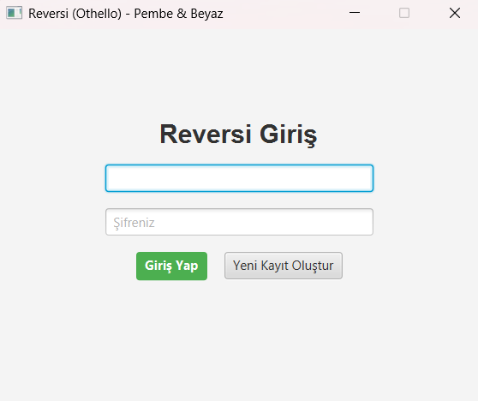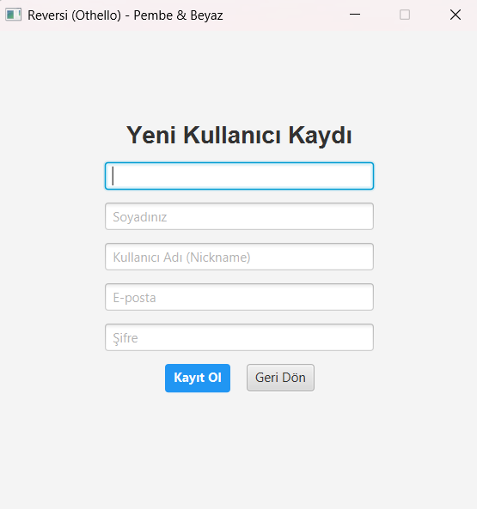

- Figure 2: Active Gameplay and UI Layout

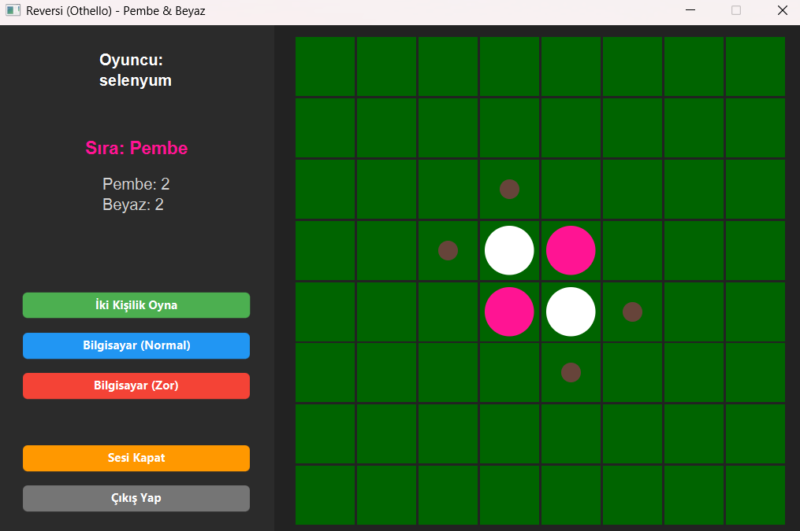

- Figure 3: Game Over and Score Evaluation
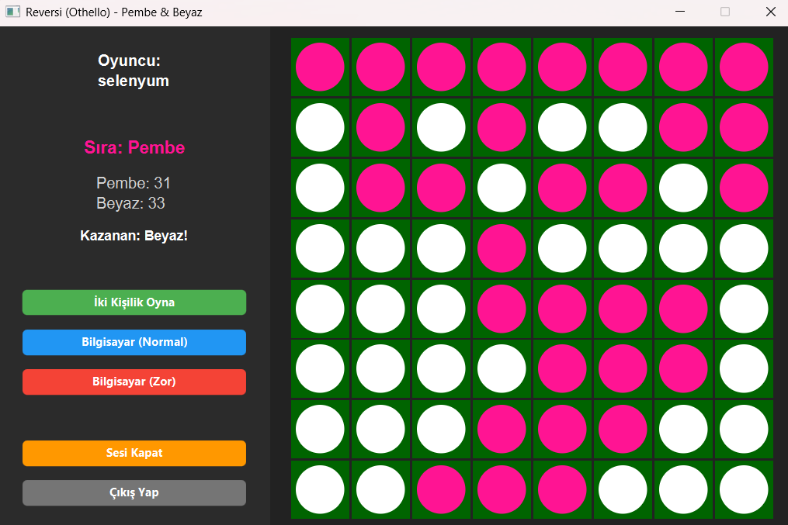
7. Conclusion
The developed Reversi application successfully integrates complex backend logic with an engaging, interactive frontend. By adhering to strict OOP principles, implementing a strategic AI, and utilizing JavaFX animations and file processing, the project fulfills all academic requirements while delivering a polished software product.

